WhatsApp Web Clone Project Documentation
Student Name: J. Rudra Teja
Admin No: AV.SC.U4CSE25114
Project: WhatsApp Web Clone using HTML, CSS and JavaScript

1. Project Overview
This project is a front-end WhatsApp Web Clone developed using HTML, CSS, and JavaScript. The application simulates the user interface and basic functionality of WhatsApp Web, including chat lists, message windows, group chats, search functionality, filters, typing indicators, automatic replies, and responsive design.

2. Objectives
- Recreate the WhatsApp Web user interface.
- Implement chat navigation and messaging features.
- Demonstrate DOM manipulation using JavaScript.
- Apply responsive web design principles.
- Simulate real-time messaging behavior.

3. Technologies Used
HTML5 – Structure of the application.
CSS3 – Styling, layout, animations and responsiveness.
JavaScript – Dynamic behavior, chat rendering and interactions.
Tabler Icons CDN – Icons used throughout the interface.

4. HTML Structure
The HTML section contains the overall structure of the application:
• Sidebar containing profile section, search bar, filters and chat list.
• Main panel displaying chat messages.
• Message input area.
• Dynamic content containers updated through JavaScript.

5. CSS Design Features
The CSS section provides:
• Dark theme similar to WhatsApp Web.
• Custom CSS variables for consistent colors.
• Responsive design using media queries.
• Hover effects and transitions.
• Chat bubble styling for incoming and outgoing messages.
• Scrollbar customization.
• Typing indicator and message animations.

6. JavaScript Functionalities
Major functions implemented:
• renderChatList() – Displays available chats.
• openChat() – Opens selected conversation.
• closeChat() – Returns to chat list on mobile.
• renderMessages() – Loads conversation messages.
• sendMsg() – Sends new messages.
• handleKey() – Sends messages using Enter key.
• filterTab() – Filters chats by category.
• Search functionality for contacts.
• Automatic simulated replies.
• Typing indicator simulation.

7. Key Features
• WhatsApp-like interface.
• Contact list with avatars.
• Online status indicators.
• Group and personal chats.
• Search contacts.
• Unread message badges.
• Responsive mobile layout.
• Auto-generated replies.
• Read receipt indicators.
• Chat filtering (All, Unread, Groups).

8. Screenshots
Figure 1: Application Screen
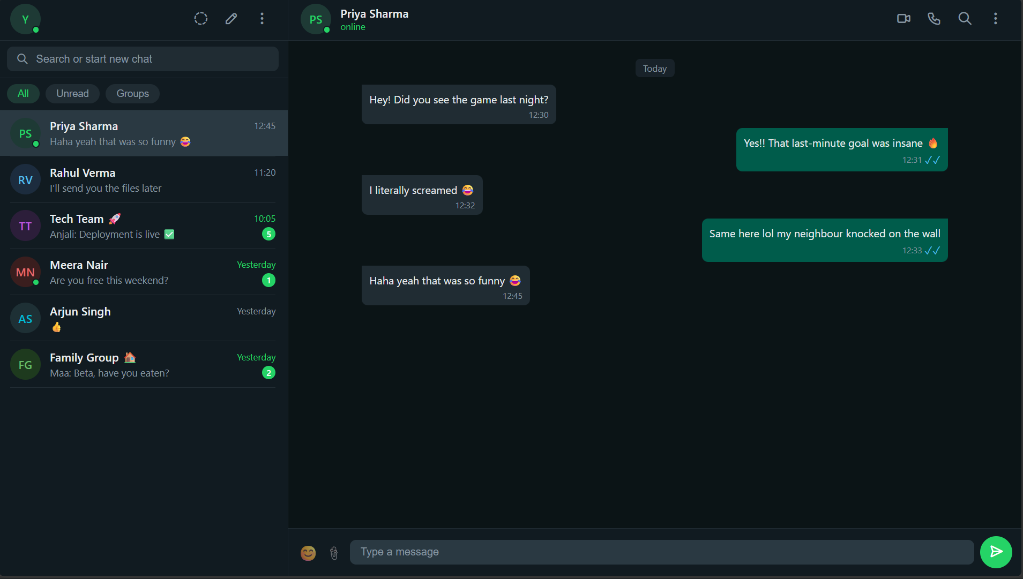
Figure 2: Application Screen
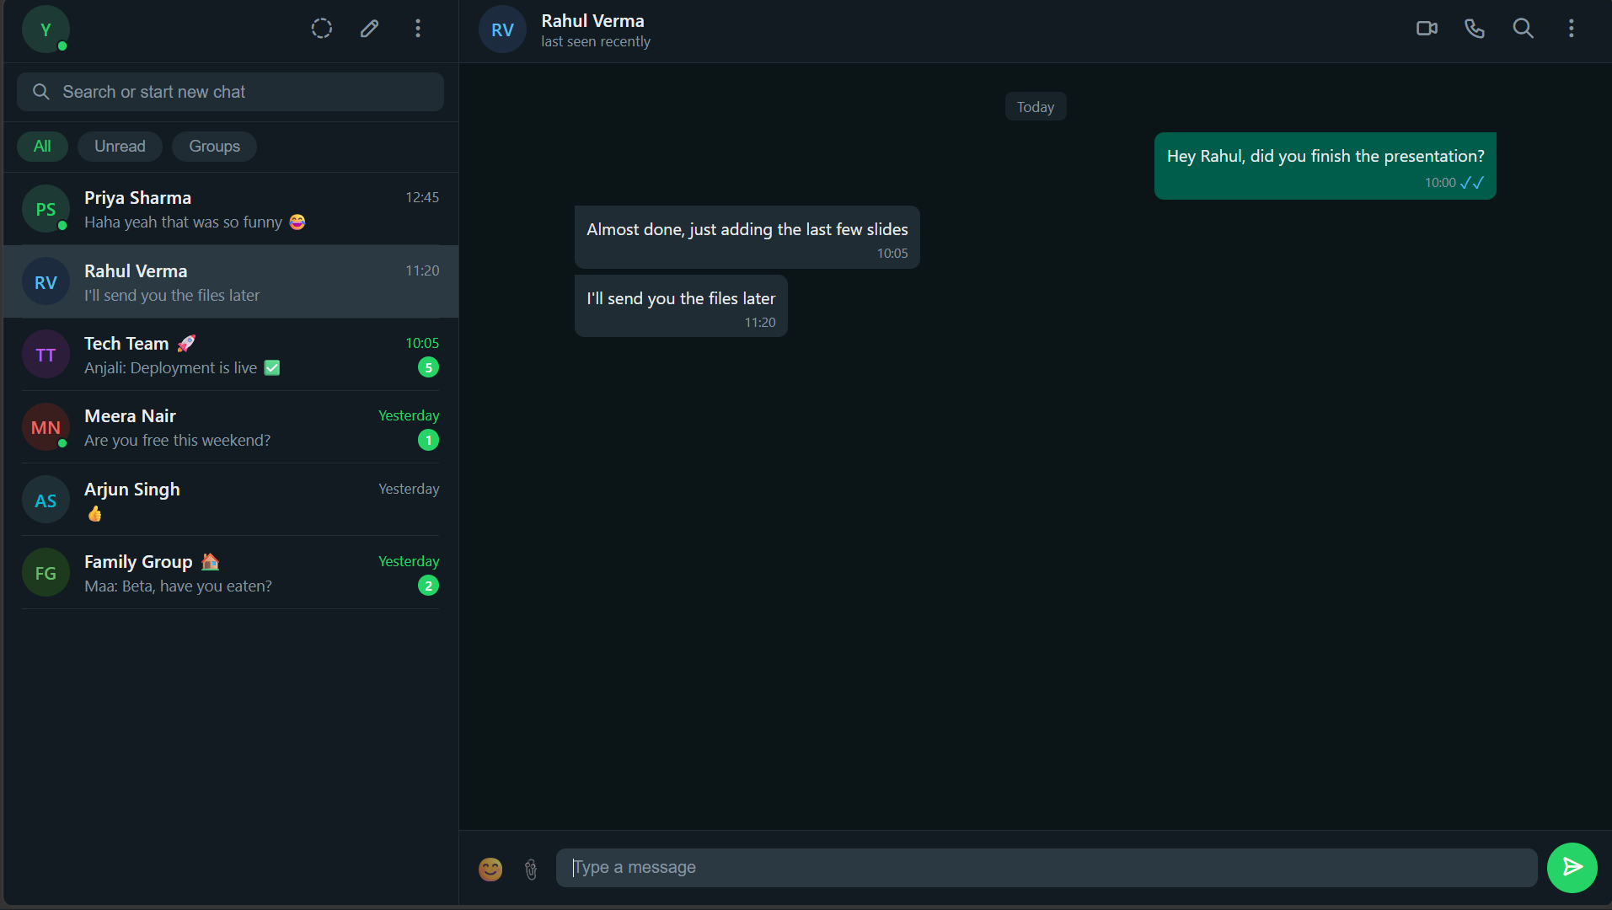
Figure 3: Application Screen
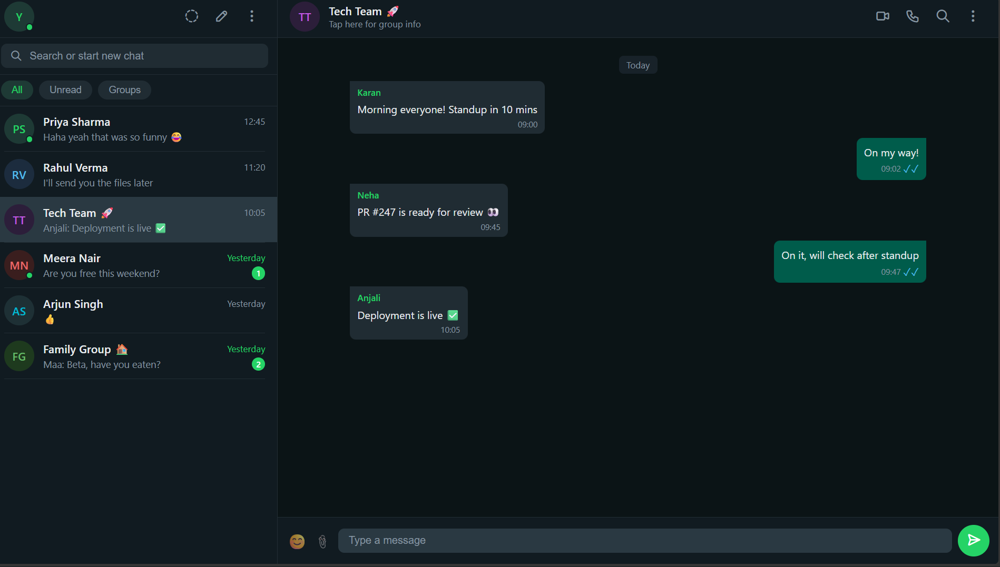
Figure 4: Application Screen
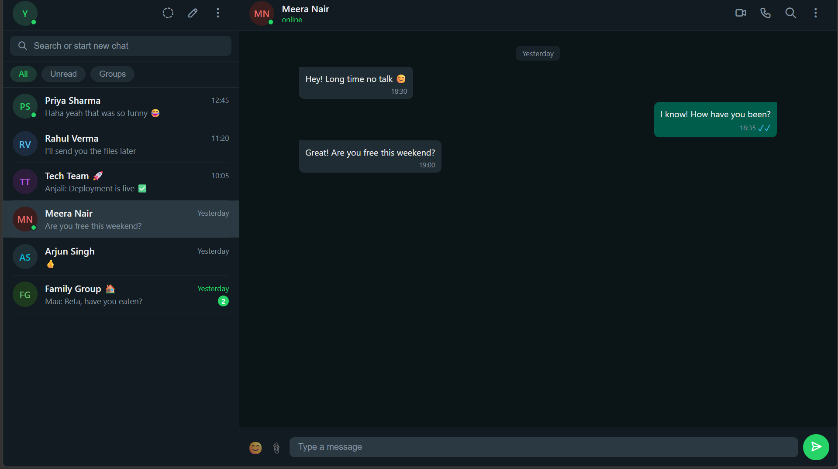
Figure 5: Application Screen
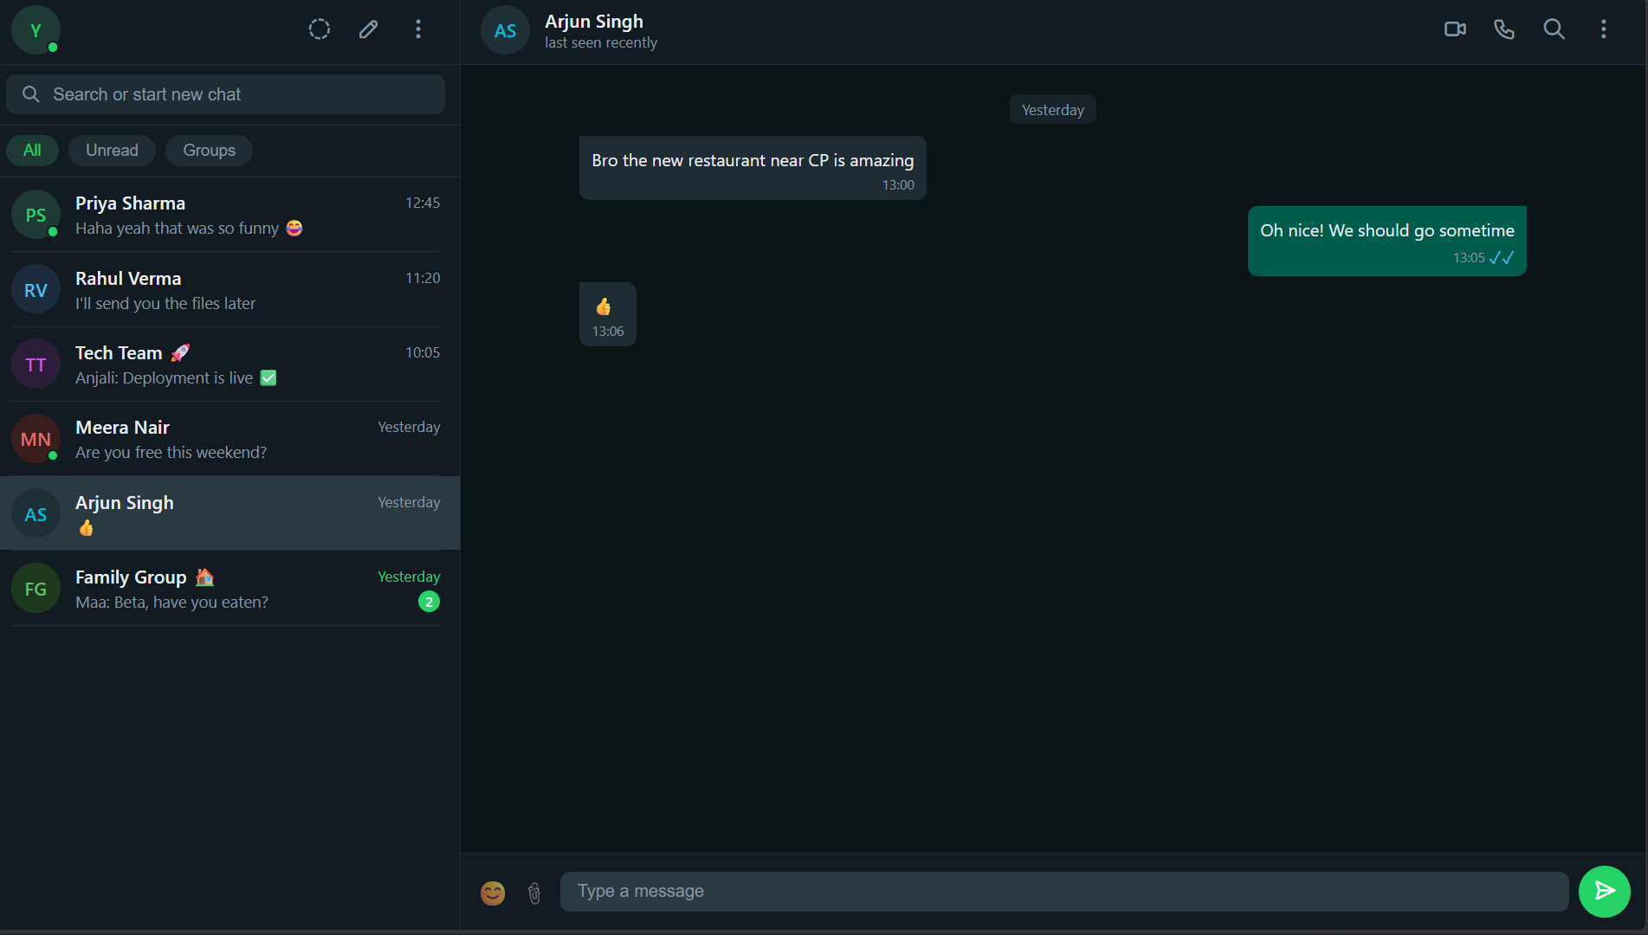
Figure 6: Application Screen
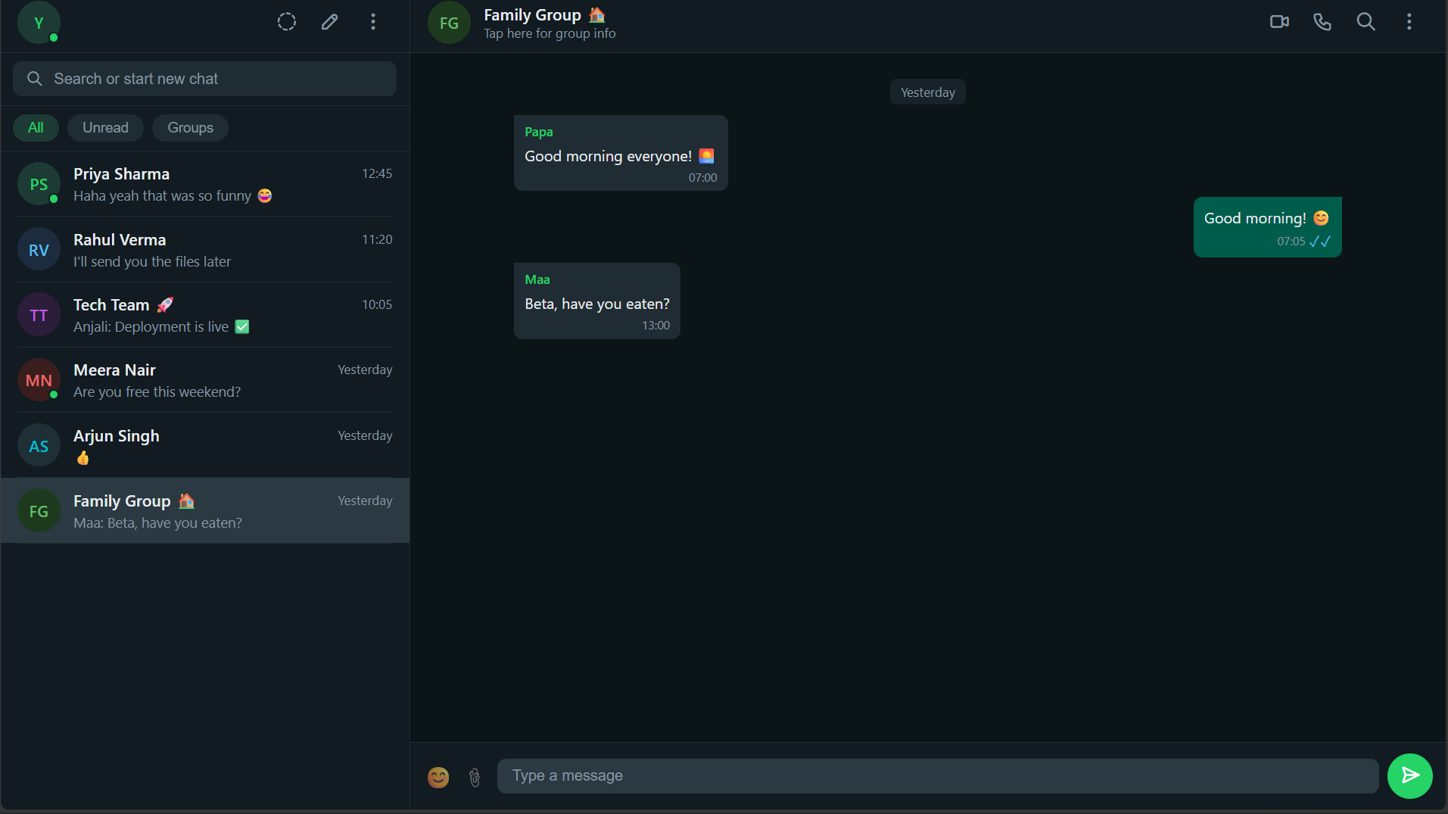

9. Advantages
• Easy to understand and maintain.
• Clean user interface.
• Demonstrates front-end development concepts.
• Responsive across devices.
• Can be extended with backend integration.

10. Future Enhancements
• Database integration.
• User authentication.
• Real-time communication using WebSockets.
• File and image sharing.
• Voice and video calling support.
• Cloud message synchronization.

11. Conclusion
The WhatsApp Web Clone successfully recreates the appearance and core interaction model of WhatsApp Web using only HTML, CSS, and JavaScript. The project demonstrates responsive design, DOM manipulation, event handling, and user interface development skills.<!DOCTYPE html>
<html lang="en">
<head>
<meta charset="UTF-8" />
<meta name="viewport" content="width=device-width, initial-scale=1.0" />
<title>WhatsApp Web Clone</title>
<link rel="stylesheet" href="https://cdn.jsdelivr.net/npm/@tabler/icons-webfont@latest/dist/tabler-icons.min.css" />
<style>
* { box-sizing: border-box; margin: 0; padding: 0; }
body { background: #0B1416; display: flex; justify-content: center; align-items: center; min-height: 100vh; font-family: 'Segoe UI', system-ui, sans-serif; }
:root {
--wa-green: #25D366;
--wa-dark-green: #128C7E;
--wa-teal: #075E54;
--wa-light-green: #DCF8C6;
--wa-panel: #111B21;
--wa-chat-bg: #0B1416;
--wa-msg-in: #202C33;
--wa-msg-out: #005C4B;
--wa-text: #E9EDEF;
--wa-text-muted: #8696A0;
--wa-border: #222D34;
--wa-hover: #202C33;
--wa-input-bg: #2A3942;
--wa-search-bg: #202C33;
}
.wa-app {
display: flex;
height: 100vh;
width: 100vw;
background: var(--wa-chat-bg);
overflow: hidden;
}
.wa-sidebar {
width: 380px;
min-width: 320px;
display: flex;
flex-direction: column;
background: var(--wa-panel);
border-right: 0.5px solid var(--wa-border);
}
.wa-sidebar-header {
display: flex;
align-items: center;
justify-content: space-between;
padding: 10px 16px;
background: var(--wa-panel);
border-bottom: 0.5px solid var(--wa-border);
height: 56px;
}
.wa-avatar {
width: 40px; height: 40px;
border-radius: 50%;
display: flex; align-items: center; justify-content: center;
font-weight: 600; font-size: 15px; cursor: pointer;
flex-shrink: 0; user-select: none;
}
.wa-header-icons { display: flex; gap: 4px; }
.wa-icon-btn {
width: 36px; height: 36px;
border-radius: 50%;
border: none; background: transparent;
cursor: pointer;
display: flex; align-items: center; justify-content: center;
color: var(--wa-text-muted);
font-size: 20px;
transition: background 0.15s;
}
.wa-icon-btn:hover { background: var(--wa-hover); color: var(--wa-text); }
.wa-search { padding: 8px 12px; border-bottom: 0.5px solid var(--wa-border); }
.wa-search-inner {
display: flex; align-items: center; gap: 10px;
background: var(--wa-search-bg);
border-radius: 8px; padding: 8px 12px;
}
.wa-search-inner input {
background: transparent; border: none; outline: none;
color: var(--wa-text); font-size: 14px; width: 100%;
}
.wa-search-inner input::placeholder { color: var(--wa-text-muted); }
.wa-filter-tabs {
display: flex; gap: 8px; padding: 8px 12px;
border-bottom: 0.5px solid var(--wa-border);
}
.wa-tab {
padding: 5px 14px;
border-radius: 99px;
border: none; cursor: pointer;
font-size: 13px; font-weight: 500;
background: var(--wa-search-bg);
color: var(--wa-text-muted);
transition: all 0.15s;
}
.wa-tab.active { background: #1E3A35; color: var(--wa-green); }
.wa-chats { flex: 1; overflow-y: auto; }
.wa-chats::-webkit-scrollbar { width: 4px; }
.wa-chats::-webkit-scrollbar-thumb { background: #3B4A54; border-radius: 2px; }
.wa-chat-item {
display: flex; align-items: center; gap: 12px;
padding: 10px 16px; cursor: pointer;
transition: background 0.12s; position: relative;
}
.wa-chat-item:hover { background: var(--wa-hover); }
.wa-chat-item.active { background: #2A3942; }
.wa-chat-info { flex: 1; min-width: 0; }
.wa-chat-row1 { display: flex; justify-content: space-between; align-items: center; margin-bottom: 2px; }
.wa-chat-name { font-size: 15px; font-weight: 500; color: var(--wa-text); white-space: nowrap; overflow: hidden; text-overflow: ellipsis; }
.wa-chat-time { font-size: 12px; color: var(--wa-text-muted); white-space: nowrap; }
.wa-chat-time.unread { color: var(--wa-green); }
.wa-chat-row2 { display: flex; justify-content: space-between; align-items: center; }
.wa-chat-preview { font-size: 13px; color: var(--wa-text-muted); white-space: nowrap; overflow: hidden; text-overflow: ellipsis; flex: 1; }
.wa-badge {
background: var(--wa-green); color: #fff;
font-size: 11px; font-weight: 600;
min-width: 18px; height: 18px;
border-radius: 99px; padding: 0 5px;
display: flex; align-items: center; justify-content: center;
margin-left: 6px; flex-shrink: 0;
}
.wa-main { flex: 1; display: flex; flex-direction: column; background: var(--wa-chat-bg); position: relative; }
.wa-main-empty {
flex: 1; display: flex; flex-direction: column;
align-items: center; justify-content: center;
color: var(--wa-text-muted); gap: 16px;
}
.wa-empty-icon {
width: 80px; height: 80px; border-radius: 50%;
background: #1E3A35;
display: flex; align-items: center; justify-content: center; font-size: 36px;
}
.wa-chat-header {
display: flex; align-items: center; gap: 12px;
padding: 10px 16px;
background: var(--wa-panel);
border-bottom: 0.5px solid var(--wa-border);
height: 56px;
}
.wa-chat-header-info { flex: 1; cursor: pointer; }
.wa-chat-header-name { font-size: 15px; font-weight: 500; color: var(--wa-text); }
.wa-chat-header-status { font-size: 12px; color: var(--wa-text-muted); }
.wa-chat-header-status.online { color: var(--wa-green); }
.wa-messages {
flex: 1; overflow-y: auto;
padding: 16px 10%;
display: flex; flex-direction: column; gap: 2px;
}
.wa-messages::-webkit-scrollbar { width: 4px; }
.wa-messages::-webkit-scrollbar-thumb { background: #3B4A54; border-radius: 2px; }
.wa-msg {
max-width: 65%; padding: 7px 10px 6px;
border-radius: 8px; position: relative;
margin-bottom: 2px; word-wrap: break-word;
}
.wa-msg-wrap { display: flex; margin-bottom: 1px; }
.wa-msg-wrap.out { justify-content: flex-end; }
.wa-msg-wrap.in { justify-content: flex-start; }
.wa-msg.in { background: var(--wa-msg-in); color: var(--wa-text); border-top-left-radius: 0; }
.wa-msg.out { background: var(--wa-msg-out); color: var(--wa-text); border-top-right-radius: 0; }
.wa-msg-text { font-size: 14px; line-height: 1.5; }
.wa-msg-meta { display: flex; align-items: center; justify-content: flex-end; gap: 3px; margin-top: 2px; }
.wa-msg-time { font-size: 11px; color: var(--wa-text-muted); }
.wa-tick { font-size: 14px; color: var(--wa-text-muted); }
.wa-tick.read { color: #53BDEB; }
.wa-date-label { text-align: center; margin: 12px 0; font-size: 12px; color: var(--wa-text-muted); }
.wa-date-label span { background: #182229; padding: 4px 10px; border-radius: 6px; }
.wa-input-area {
display: flex; align-items: center; gap: 8px;
padding: 10px 12px;
background: var(--wa-panel);
border-top: 0.5px solid var(--wa-border);
}
.wa-input-box {
flex: 1; background: var(--wa-input-bg);
border-radius: 8px;
display: flex; align-items: center; gap: 8px;
padding: 8px 14px;
}
.wa-input-box input {
flex: 1; background: transparent; border: none; outline: none;
color: var(--wa-text); font-size: 14px;
}
.wa-input-box input::placeholder { color: var(--wa-text-muted); }
.wa-send-btn {
width: 42px; height: 42px; border-radius: 50%;
background: var(--wa-green); border: none; cursor: pointer;
display: flex; align-items: center; justify-content: center;
color: #fff; font-size: 20px;
transition: background 0.15s, transform 0.1s; flex-shrink: 0;
}
.wa-send-btn:hover { background: var(--wa-dark-green); }
.wa-send-btn:active { transform: scale(0.95); }
.wa-typing { font-size: 13px; padding: 4px 10% 0; color: var(--wa-green); display: none; height: 20px; }
.wa-typing.show { display: block; }
.wa-msg-new { animation: fadeIn 0.2s ease; }
@keyframes fadeIn { from { opacity: 0; transform: translateY(8px); } to { opacity: 1; transform: none; } }
.wa-divider { height: 0.5px; background: var(--wa-border); margin: 0 16px; }
.wa-status-dot {
width: 10px; height: 10px; border-radius: 50%;
background: var(--wa-green);
position: absolute; bottom: 1px; right: 1px;
border: 2px solid var(--wa-panel);
}
.wa-avatar-wrap { position: relative; flex-shrink: 0; }
.wa-emoji-btn { font-size: 20px; background: none; border: none; cursor: pointer; opacity: 0.6; }
.wa-emoji-btn:hover { opacity: 1; }

/* Responsive */
@media (max-width: 700px) {
.wa-sidebar { width: 100%; min-width: unset; }
.wa-main { display: none; }
.wa-app.chat-open .wa-sidebar { display: none; }
.wa-app.chat-open .wa-main { display: flex; width: 100%; }
}
</style>
</head>
<body>
<div class="wa-app" id="waApp">
<!-- Sidebar -->
<div class="wa-sidebar">
<div class="wa-sidebar-header">
<div class="wa-avatar-wrap">
<div class="wa-avatar" style="background:#1E3A35;color:var(--wa-green)">Y</div>
<div class="wa-status-dot"></div>
</div>
<div class="wa-header-icons">
<button class="wa-icon-btn" title="Status"><i class="ti ti-circle-dashed"></i></button>
<button class="wa-icon-btn" title="New Chat"><i class="ti ti-pencil"></i></button>
<button class="wa-icon-btn" title="Menu"><i class="ti ti-dots-vertical"></i></button>
</div>
</div>
<div class="wa-search">
<div class="wa-search-inner">
<i class="ti ti-search" style="color:var(--wa-text-muted);font-size:16px"></i>
<input type="text" placeholder="Search or start new chat" id="searchInput" />
</div>
</div>
<div class="wa-filter-tabs">
<button class="wa-tab active" onclick="filterTab(this,'all')">All</button>
<button class="wa-tab" onclick="filterTab(this,'unread')">Unread</button>
<button class="wa-tab" onclick="filterTab(this,'groups')">Groups</button>
</div>
<div class="wa-chats" id="chatList"></div>
</div>

<!-- Main Panel -->
<div class="wa-main" id="mainPanel">
<div class="wa-main-empty" id="emptyState">
<div class="wa-empty-icon">💬</div>
<div style="text-align:center">
<p style="color:var(--wa-text);font-size:16px;font-weight:500;margin-bottom:6px">WhatsApp Web</p>
<p style="font-size:13px;max-width:280px;line-height:1.6">Send and receive messages without keeping your phone online.</p>
</div>
</div>
</div>
</div>

<script>
const contacts = [
{ id:1, name:'Priya Sharma', avatar:'PS', color:'#1E3A35', acolor:'var(--wa-green)', preview:'Haha yeah that was so funny 😂', time:'12:45', unread:3, online:true, isGroup:false,
messages:[
{id:1,text:'Hey! Did you see the game last night?',out:false,time:'12:30',read:true},
{id:2,text:'Yes!! That last-minute goal was insane 🔥',out:true,time:'12:31',read:true},
{id:3,text:'I literally screamed 😂',out:false,time:'12:32',read:true},
{id:4,text:'Same here lol my neighbour knocked on the wall',out:true,time:'12:33',read:true},
{id:5,text:'Haha yeah that was so funny 😂',out:false,time:'12:45',read:false},
]
},
{ id:2, name:'Rahul Verma', avatar:'RV', color:'#1C2C3E', acolor:'#53BDEB', preview:"I'll send you the files later", time:'11:20', unread:0, online:false, isGroup:false,
messages:[
{id:1,text:'Hey Rahul, did you finish the presentation?',out:true,time:'10:00',read:true},
{id:2,text:'Almost done, just adding the last few slides',out:false,time:'10:05',read:true},
{id:3,text:"I'll send you the files later",out:false,time:'11:20',read:true},
]
},
{ id:3, name:'Tech Team 🚀', avatar:'TT', color:'#2C1E3A', acolor:'#C45AE6', preview:'Anjali: Deployment is live ✅', time:'10:05', unread:5, online:false, isGroup:true,
messages:[
{id:1,text:'Morning everyone! Standup in 10 mins',out:false,time:'09:00',read:true,sender:'Karan'},
{id:2,text:'On my way!',out:true,time:'09:02',read:true},
{id:3,text:'PR #247 is ready for review 👀',out:false,time:'09:45',read:true,sender:'Neha'},
{id:4,text:'On it, will check after standup',out:true,time:'09:47',read:true},
{id:5,text:'Deployment is live ✅',out:false,time:'10:05',read:false,sender:'Anjali'},
]
},
{ id:4, name:'Meera Nair', avatar:'MN', color:'#3A1E1E', acolor:'#E66A6A', preview:'Are you free this weekend?', time:'Yesterday', unread:1, online:true, isGroup:false,
messages:[
{id:1,text:"Hey! Long time no talk 😊",out:false,time:'Yesterday 18:30',read:true},
{id:2,text:'I know! How have you been?',out:true,time:'Yesterday 18:35',read:true},
{id:3,text:'Great! Are you free this weekend?',out:false,time:'Yesterday 19:00',read:false},
]
},
{ id:5, name:'Arjun Singh', avatar:'AS', color:'#1E3035', acolor:'#00BCD4', preview:'👍', time:'Yesterday', unread:0, online:false, isGroup:false,
messages:[
{id:1,text:'Bro the new restaurant near CP is amazing',out:false,time:'Yesterday 13:00',read:true},
{id:2,text:'Oh nice! We should go sometime',out:true,time:'Yesterday 13:05',read:true},
{id:3,text:'👍',out:false,time:'Yesterday 13:06',read:true},
]
},
{ id:6, name:'Family Group 🏠', avatar:'FG', color:'#1E3A1E', acolor:'#66BB6A', preview:'Maa: Beta, have you eaten?', time:'Yesterday', unread:2, online:false, isGroup:true,
messages:[
{id:1,text:'Good morning everyone! 🌅',out:false,time:'Yesterday 07:00',read:true,sender:'Papa'},
{id:2,text:'Good morning! 😊',out:true,time:'Yesterday 07:05',read:true},
{id:3,text:'Beta, have you eaten?',out:false,time:'Yesterday 13:00',read:false,sender:'Maa'},
]
},
];

let activeId = null;
let typingTimer = null;
let activeFilter = 'all';

const replies = {
1: ["😂 Right??","That was crazy!","We should watch the next one together!","Agreed 💯","Haha for real 😂"],
2: ["Ok sounds good 👍","Let me know when it's ready","No rush!","Thanks Rahul!","Got it!"],
3: ["Thanks for the update!","Looks good!","On it 🔥","Will review soon","Nice work everyone!"],
4: ["Yes I'm free! 😊","Sounds fun!","Let me check my schedule","I'd love that!","Tell me more!"],
5: ["Let's go this weekend?","Sounds amazing!","Add me in!","Nice 👍","Definitely going!"],
6: ["Yes Maa, just ate! 😊","Hi everyone!","Miss you all ❤️","Coming home soon!","Love you all!"],
};

function now() {
const d = new Date();
return d.getHours().toString().padStart(2,'0') + ':' + d.getMinutes().toString().padStart(2,'0');
}

function renderChatList(filter) {
filter = filter || activeFilter;
const list = document.getElementById('chatList');
const search = document.getElementById('searchInput').value.toLowerCase();
const filtered = contacts.filter(c => {
if (search && !c.name.toLowerCase().includes(search)) return false;
if (filter === 'unread') return c.unread > 0;
if (filter === 'groups') return c.isGroup;
return true;
});
list.innerHTML = filtered.map(c => `
<div class="wa-chat-item${activeId === c.id ? ' active' : ''}" onclick="openChat(${c.id})" id="chat-item-${c.id}">
<div class="wa-avatar-wrap">
<div class="wa-avatar" style="background:${c.color};color:${c.acolor}">${c.avatar}</div>
${c.online ? '<div class="wa-status-dot"></div>' : ''}
</div>
<div class="wa-chat-info">
<div class="wa-chat-row1">
<span class="wa-chat-name">${c.name}</span>
<span class="wa-chat-time${c.unread ? ' unread' : ''}">${c.time}</span>
</div>
<div class="wa-chat-row2">
<span class="wa-chat-preview">${c.preview}</span>
${c.unread ? `<span class="wa-badge">${c.unread}</span>` : ''}
</div>
</div>
</div>
<div class="wa-divider"></div>
`).join('');
}

function openChat(id) {
activeId = id;
const c = contacts.find(x => x.id === id);
c.unread = 0;
renderChatList();

// Mobile: show main panel
document.getElementById('waApp').classList.add('chat-open');

const main = document.getElementById('mainPanel');
main.innerHTML = `
<div class="wa-chat-header">
<button class="wa-icon-btn" onclick="closeChat()" title="Back" style="display:none" id="backBtn">
<i class="ti ti-arrow-left"></i>
</button>
<div class="wa-avatar-wrap">
<div class="wa-avatar" style="background:${c.color};color:${c.acolor};width:40px;height:40px">${c.avatar}</div>
${c.online ? '<div class="wa-status-dot"></div>' : ''}
</div>
<div class="wa-chat-header-info">
<div class="wa-chat-header-name">${c.name}</div>
<div class="wa-chat-header-status${c.online ? ' online' : ''}">${c.online ? 'online' : c.isGroup ? 'Tap here for group info' : 'last seen recently'}</div>
</div>
<div class="wa-header-icons">
<button class="wa-icon-btn" title="Video call"><i class="ti ti-video"></i></button>
<button class="wa-icon-btn" title="Voice call"><i class="ti ti-phone"></i></button>
<button class="wa-icon-btn" title="Search"><i class="ti ti-search"></i></button>
<button class="wa-icon-btn" title="Menu"><i class="ti ti-dots-vertical"></i></button>
</div>
</div>
<div class="wa-messages" id="messages"></div>
<div class="wa-typing" id="typingIndicator">typing...</div>
<div class="wa-input-area">
<button class="wa-emoji-btn" title="Emoji">😊</button>
<button class="wa-emoji-btn" title="Attach" style="font-size:18px">📎</button>
<div class="wa-input-box">
<input type="text" placeholder="Type a message" id="msgInput" onkeydown="handleKey(event)" />
</div>
<button class="wa-send-btn" onclick="sendMsg()" title="Send">
<i class="ti ti-send-2"></i>
</button>
</div>
`;

// Show back button on mobile
if (window.innerWidth <= 700) {
document.getElementById('backBtn').style.display = 'flex';
}

renderMessages(id);
setTimeout(() => { const inp = document.getElementById('msgInput'); if (inp) inp.focus(); }, 50);
}

function closeChat() {
document.getElementById('waApp').classList.remove('chat-open');
activeId = null;
renderChatList();
}

function renderMessages(id) {
const c = contacts.find(x => x.id === id);
const box = document.getElementById('messages');
if (!box) return;
let lastDate = '';
let html = '';
c.messages.forEach(m => {
const dateLabel = m.time.includes('Yesterday') ? 'Yesterday' : 'Today';
if (dateLabel !== lastDate) {
html += `<div class="wa-date-label"><span>${dateLabel}</span></div>`;
lastDate = dateLabel;
}
const tick = m.out ? (m.read ? '<span class="wa-tick read">✓✓</span>' : '<span class="wa-tick">✓✓</span>') : '';
const sender = (c.isGroup && !m.out && m.sender) ? `<div style="font-size:12px;color:var(--wa-green);font-weight:500;margin-bottom:3px">${m.sender}</div>` : '';
html += `
<div class="wa-msg-wrap ${m.out ? 'out' : 'in'}">
<div class="wa-msg ${m.out ? 'out' : 'in'}">
${sender}
<span class="wa-msg-text">${m.text}</span>
<div class="wa-msg-meta">
<span class="wa-msg-time">${m.time.replace('Yesterday ', '').replace('Today ', '')}</span>
${tick}
</div>
</div>
</div>`;
});
box.innerHTML = html;
box.scrollTop = box.scrollHeight;
}

function handleKey(e) {
if (e.key === 'Enter') sendMsg();
}

function sendMsg() {
const input = document.getElementById('msgInput');
if (!input || !activeId) return;
const text = input.value.trim();
if (!text) return;
input.value = '';
const c = contacts.find(x => x.id === activeId);
const t = now();
c.messages.push({ id: Date.now(), text, out: true, time: t, read: false });
c.preview = text;
c.time = t;
renderMessages(activeId);
renderChatList();
const typing = document.getElementById('typingIndicator');
if (typing) typing.classList.add('show');
clearTimeout(typingTimer);
typingTimer = setTimeout(() => {
if (typing) typing.classList.remove('show');
const pool = replies[activeId] || ['Ok!', 'Got it!', 'Sure!', '👍', 'Thanks!'];
const reply = pool[Math.floor(Math.random() * pool.length)];
const rt = now();
c.messages.push({ id: Date.now() + 1, text: reply, out: false, time: rt, read: false, sender: c.isGroup ? c.name.split(' ')[0] : undefined });
c.preview = reply;
c.time = rt;
c.unread = 0;
renderMessages(activeId);
renderChatList();
}, 1400 + Math.random() * 600);
const inp = document.getElementById('msgInput');
if (inp) inp.focus();
}

function filterTab(el, filter) {
document.querySelectorAll('.wa-tab').forEach(t => t.classList.remove('active'));
el.classList.add('active');
activeFilter = filter;
renderChatList(filter);
}

document.getElementById('searchInput').addEventListener('input', () => renderChatList(activeFilter));

renderChatList();
openChat(1);
</script>
</body>
</html>

